EXP 1:
AIM : To create a table named STUDENT with the specified fields such as RegNo, Name, Gender, DOB, MobileNo, and City using appropriate data types.
QUERY FOR TABLE :
CREATE TABLE STUDENT (
RegNo INT(3) PRIMARY KEY,
Name VARCHAR(15),
Gender CHAR(1),
DOB DATE,
MobileNo BIGINT,
City VARCHAR(15)
);
QUERY FOR VALUES :
INSERT INTO STUDENT
(RegNo, Name, Gender, DOB, MobileNo, City)
VALUES
(101, 'JOHN', 'M', '2005-05-02', 1212121212, 'HYDERABAD'),
(102, 'VIKRAM', 'M', '2005-11-12', 1234567890, 'CHENNAI'),
(103, 'PRIYA', 'F', '2004-08-15', 9876543210, 'BANGALORE'),
(104, 'JAYA', 'F', '2004-09-09', 1234123412, 'GUNTUR'),
(105, 'LOHITH', 'M', '2008-06-02', 1234567890, 'TIRUPATHI');
To display all the inserted records:
SELECT * FROM STUDENT;
OUTPUT :
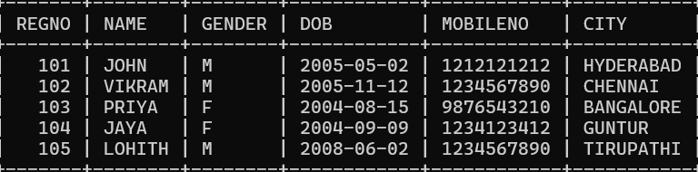
Result :
The STUDENT table was created successfully with the specified structure.

